

***SCHOOL BILLING SYSTEM***

BY

***SADIA SUBRUN PROMA***

***( ID: 181-35-2295)***

A course project (SWE 133: Software Engineering project-I) submitted in

Fulfillment of the requirement for the degree of Bachelor of Science in

Software Engineering

***Department of Software Engineering***

***DAFFODIL INTERNATIONAL UNIVERSITY***

Fall-2018

**Copyright © 2018 by Daffodil International University**

***DECLARATION***

It hereby declared that this course project title on ”***SCHOOL BILLING SYSTEM***”Under the supervision of ***Dr. Md. Asraf Ali,Associate Professor,Department of Software Engineering,Daffodil international University.***It is also declared that neither this project nor any part of this has been submitted elsewhere for award or any degree.

***--------------------------------***

***Student:***

***Name: Sadia Subrun Proma***

***ID: 181-35-2295***

Batch:25th

Department of Software Engineering

Faculty of Science & Information Technology

Daffodil International University

Certified by:

***-------------------------------***

***Dr. Md. Asraf Ali***

Associate Professor

Department of Software Engineering

Faculty of Science & information Technology

Daffodil International University

***ACKNOWLEDGEMENT***

First of all,I am grateful to The Almighty God for giving me the ability to complete this project.Today I am feling proud of myself.Becouse,to be a student of Daffodil International University.And I am thankful to Daffodil International University for giving me a chance to give me a chance to prove myself by showing this project.I thank to our Department Head Dr. Touhid Bhuiyan.And I want to thank to our respected class teacher Dr. Md. Asraf Ali for supporting and given your guideline and valuable advices.

School billing system is not a new system.But my software will give you better experience.I hope every people will use this system will be happy after completing their transaction.

To made this software I have collected many types of information from different types school and internet sources.And also my friend help to built this software.

Thank you

Sadia subrun proma

**TABLE OF CONTANT**

**DECLARATION…………………………………………………………………………………..*2***

**ACKNOWLEDGEMENT……………………………………………………………..*3***

**TABLE OF CONTENT………………………………………………………………………….*4***

**LIST OF FIGURE…………………………………………………………………………………*7***

**LIST OF ABBREVIATIONS…………………………………………………………………*8***

**ABSTRACT…………………………………………………………………………………………*9***

**CHAPTER 1: INTRODUCTION**………………………………………………………………...10

* 1. Background……………………………………………………………………………………10
  2. Project Objective……………………………………………………………………………11
  3. Feasibility study……………………………………………………………………………..11
  4. Benefits…………………………………………………………………………...…………....12
  5. Scope &limitation……………………………………………………………………………12

**CHAPTER 2: LITERATURE REVIEW…………..…………………………………………….12**

**CHAPTER 3: METHODOLOGY….…………………………………………………………….13**

3.1 Date choice…………………………………………………………………………………….14

3.2 Account types………………………………………………………………………………..14

3.2.1 Student……………………………………………………………………………………14

3.2.1.1 Add record……………………..………………………………………………….15

3.2.1.2 Search record……………………………………………………………………..15

3.1.1.3 Modify record..…………………………………………………………………..15

3.1.1.4 Delete record………………………………………………………………………15

3.1.1.5 Calculate fee.……………………………………………………………………..15

3.1.1.6 Exit……………………………………………………………………………………15

3.2.2 Teacher & staff ………………………………………………………………………….15

3.2.2.1 Add record…………………………………………………………………………16

3.2.2.2 Search record…………………………………………………………………….16

3.2.2.3 Modify record…………………………………………………………………….16

3.2.2.4 Delete record……………………………………………………………………..16

3.2.2.5 Calculate…………………..………………………………………………………..16

3.2.2.6 Exit………………………………………………………………………………………16

3.2.3 Exit……………………………………………………………………………………….......17

3.3 Functional requirement…………………………………………………………………..17

3.4 Non Functional requirement…………………………………………………………..18

**CHAPTER 4: RESULTS AND DISCUSSION………………………………………………….18**

4.1 Main menu………………………………………………………………………………………19

4.1 Date choice……………………………………………………………………………………...20

4.2 Account types………………………………………………………………………………..…21

4.3 Student…………………………………………………………………………………………….22

4.4 Teacher and staff………………………………………………………………………..……22

4.5 Add record……………………………………………………………………………………….23

4.6 Search record…………………………………………………………………………………..23

4.7 Modify record………………………………………………………………………………….24

4.8 Delete record……………………………………………………………………….............25

4.9 Calculate fee…………………………………………………………………………………….25

4.10 Calculate salary……………………..……………………………………………………….24

**CHAPTER 5: CONCLUSIONS AND RECOMMENDATIONS…………………………26**

5.1 Findings and Contributions..…………………………………………………………...26

5.2 Recommendations for Future Works……………………………………………….26

**CHAPTER 6: CONCLUSION……………………………………………………………………..26**

**APPENDIX A…………………………………………………………………………………………26**

**APPENDIX** **B…………………………………………………………………………………………28**

**APPENDIX C…………………………………………………………………………………………32**

**APPENDIX D………………………………………………………………………………………..35**

**APPENDIX E………………………………………………………………………………………..41**

**APPENDIX F…………………………………………………………………………………………48**

**APPENDIX G……………………………………………………………………………………….52**

**APPENDIX H..........................................................................................54**

**APPENDIX I………………………………………………………………………………………….57**

**APPENDIX J………………………………………………………………………………………….58**

**LIST OF FIGURE**

Figure 4.1 : Main menu……………………………………………………………………………….19

Figure 4.2: Date choice………………………………………………………………………………..20

Figure 4.3: Account types……………………………………………………………………………21

Figure 4.4: Student…….………………………………………………………………………………22

Figure 4.5: Teacher & staff ……………………………………………………………………….22

Figure 4.6: Add record……………………………………………………………………………….23

Figure 4.7: Search record……..……………………………………………………………………23

Figure 4.8: Modify record..…………………………………………………………………………24

Figure 4.9: Delete record……………………………………………………………………………24

Figure 4.10: Calculate fee……………………………………………………………………………25

Figure 4.11: Calculate salary………………………………………………………………………25

**LIST OF ABBREVIATIONS**

**Given below all abbreviations:**

1.DIU=Daffodil International University

2.SWE=Software Engineering

**SCHOOL BILLING SYSTEM**

**ABSTRACT**

This project basically manages the school billing process.It is a billing system that will make more easy to makes every schools different types of bill.This is a c project.During the making of this project I explored new ideas and functionality.The report reflects my steps taken at various levels of programming skills.But main objectives of this project is to build a software for making a school billing management easy and within short time.

**CHAPTER 1: INTRODUCTION**

In this project,you can add,record,modify,search and delete records of both account types.In addition to that,this project in c allows you to disply fee,dues,total and advance of students, and salary-related information of teachers and staffs.

For the entry of records,current date,month and year is asked.Then you can select the account type, and perform billing operations like I mentioned above.In the add recorde, the name,class and roll no. of the student is asked and it is similar for all other functions as well as the teachers account.

* 1. **BACKGROUND**

School billing is a very common task for any school which has a number of employees and student.Though the method differ from organization to organization.The shool management system of the earlier times had a manual system using ledger books to keep track of every single employee’s salary and student fee history,calculate.This pen and paper based system is much time consuming and there is a great chance to make mistake as there are very good number of employees and student in this organization and keeping patience is a tough job to manipulate so many things.Unauthorized persons however, easily accessed the paper system and hence making it impossible to keep secrecy.So such a system is time consuming prone to errors of entry and analysis resulting from the fatigue of the users.

Now if we view the system from the employees and student(who are the end user of the system) point of view,then the system is also monotonous .Because if one employee/student wants to check his/her statistics of salary/fee record then it is very difficult to get it without any help of automated system.

So, it is obvious to migrate the whole process in an automated way so that which help the authority and user to maintain all the things with ease.

* 1. **PROJECT OBJECTIVE**

**General objective :**

This study aimed to help a school to have an effective way of monitoring their staff/student salary/fees to give a higher quality of service.

**Specific objective:**

*Develop a system that will improve the school process in the timekeeping and maintaining accounts.

*Develop a system that will monitor teacher/student date that is efficient to use.

*Secure the records of teacher/student and to have more manageable files,managed by the administrator of the depertment.

*Calculate salary/fee transaction easily

*Summarize all the accounts detail of teacher/student.

**1.3 FEASIBILITY STUDY**

Before developing this project we need a feasibility study to understand whether the project would be successful or not.

**Technology and system feasibility:**

The assessment is based on an outline design of system requirements,to determine whether the company has the technical expertise to handle completion of the project.In our case, ‘the peoples university of Bangladesh has an efficient IT department and the personnel from the accounts department has that expertise.

**Economic feasibility:**

Economic analysis is the most frequently used method for evaluating the effectiveness of a new system.

More commonly known as cost/benefit analysis,the procedure is to determine the benefits and savings that are expected from a candidate system and compare them with cost.if benefits outweigh costs, them the decision is made to design and implement the system.The analysis must accurately weight the cost versus benefits before taking an action.

It is important to identify cost and benefit factors,which can be categorized as follows: 1. Development cost and 2. Operating costs.This is an analysis of the costs to be incurred in the system and the benefits derivable out of the system.

**1.4 BENEFITS**

*Interact with the software with menu-driven programs with user friendly interface.

*Manage employee information efficiently

*Maintain student data efficiently.

*Manage the data

*Efficiently manage the salary taken by the employees

*Prepare the detailed salary record of the employees in an organization

* 1. **SCOPE AND LIMITATION**

The proposed school billing system will cover many aspects of time keeping and fee/salary process. This includes the capture of information based on the employees work schedule,time worked and daily time rendered. The software process encompasses all activities necessary to report employees time worked.

*The system will have a file management where it covers the records of staff/student

*The system also covers the tracking of salary/fees of staff/student

**LIMITATION**

The proposed system cannot be accessed online and it focuses only on the school billing system software of the organization.This proposed system is only applicable and can only be used by the management of any school. The proposed system may face data redundancy.

**CHAPTER 2: LITERATURE REVIEW**

In our daily life we are dependent on school billing system from our childhood.But we do not want to know how the billing system is. How manage all the things. There are so many existing projects like this.

**2.1 EXISTING PROJECT**

There are so many project about school billing system.I saw some of them but I was not full of satisfied.Some project has a little things to do.Lots of things can be added with that.Then it will be more user friendly and helpful to manage any department store.

I have tried to this project user friendly to the user.I added many things and this system user may be satisfied.

**CHAPTER 3 : METHODOLOGY**

At first needed to entered date, month and year. After successfully entered date, month and year you can select the account types.

**3.1 DATE CHOICE**

In this system, at first for the entry of records,current date, month and year is asked.

**3.2 ACCOUNT TYPES**

After successfully entered date, month and year you can

choice the account types.There is also an exit option.If you do not want to continue the system then you can exit it. There are 2 types account types.They are:

1. *STUDENT*
2. *TEACHER/STAFF*
3. *EXIT*

**3.2.1 Student**

Here is the student records.System will automatically calculate all the record of students.There are different types of record.There is also an exit option. It you do not want to continue the system then you can exit it.The options are:

1. *ADD RECORD*
2. *SEARCH RECORD*
3. *MODIFY RECORD*
4. *DELETE RECORD*
5. *CALCULATE FEE*
6. *EXIT*
   * + 1. **Add record**

Here the name, class and roll no. of the student is asked and it is similar for all other functions as well as the teachers account**.**

* + - 1. **Search record**

Here you can search record of a student by name,by roll or by class.Here is also an exit option.

* + - 1. **Modify record**

Here you can modify record of a student by name,by name and roll or by name,roll and class.There is also an exit option.

* + - 1. **Delete record**

This option will help you if you to delete any record from this file record.

* + - 1. **Calculate fee**

This is an important option if you want calculate fee.It will automatically calculate the fee of every student.

* + - 1. **Exit**

This option is for exit the total system.

* + 1. **Teacher and staff**

Here is the teacher or staffs records. System will automatically calculate all the record of employees. There are different types of record.There is also an exit option. If you do not want to continue the system then you can exit it.The options are:

1. *ADD RECORD*
2. *SEARCH RECORD*
3. *MODIFY RECORD*
4. *DELETE RECORD*
5. *CALCULATE SALARY*
6. *EXIT*

**3.2.2.1 Add record**

Here the name and id of a employee is asked and it is similar for all other functions as well as the student account.

**3.2.2.2 Search record**

Here you can search record of a employee by name or id of the employee.Here also an exit option.

**3.2.2.3 Modify record**

Here you can modify record of a emplyee by name,by name and id.There is also an exit option.

* + - 1. **Delete record**

This option will help you if you to delete any record from this file record.

* + - 1. **Calculate salary**

This is an important option if you want calculate salary.It will automatically calculate the salary of every emplyee.

* + - 1. **Exit**

This option is for exit the total system.

**3.2.3 Exit**

This option is for exit the total system.

* 1. **FUNCTIONAL REQUIREMENT**

1. Date choice
2. Account types
3. Student

1.Add record

2.Search record

3.Modify record

4.Delete record

5.Calculate fee

6.Exit

1. Teacher/staff

1.Add record

2.Search record

3. Modify record

4.Delete record

5.Calculate salary

6.Exit

1. Exit
   1. **NON FUNTIONAL REQUIREMENT**
2. Security
3. Usability
4. Maintainability
5. Performance

**CHAPTER 4 : RESULT & DISCUSSION**

In this chapter we will focuses on analysis and description of every options of this system.

In this project, you can add, record,modify and delete the records of both account types.In addition to that, this project in c allows you to display fee, due,total and advance of students and salary related information of teachers and staffs.

For the entry of records,current date,month and year is asked.Then you can select the account type, and perform billing operations like I mentioned above.In the add recorde, the name,class and roll no. of the student is asked and it is similar for all other functions as well as the teachers account.

Data structures have been used effectively to handle co-related functions and store the record.

This school billing system c project comprises the following data structures:

Struct dat-to store the date(day,month & year)of entry of records

Struct student- To store and organize the record of individual students

Struct teacher-To store and organize the record of individual teachers/staffs

I have used the different function for performing different billing operations in school billing system. Listed below are some functions which will give you an outline of the project and help you understand it better.

Start()- shows the account selection screen

Chk dat()- for checking date

Addrec()- for adding records

Modrec()- for modifying records

Searchrec()- for searching records

Delrec()- for deleting record

Feerec()- for recording the fee paid and displaying fine,due,tota and advance

Salary()- for calculating the salary of teachers &staffs

Ext()- for exiting

**4.1 Main menu**

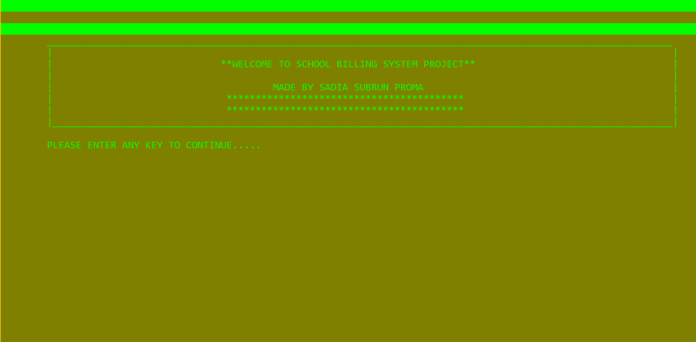

Main menu is the first user gets to see, while running the school billing software.

The user gets following options with their specific functioning after the date menu; to choice from the menu screen:-----

1. Student- to access student record.
2. Teacher- to access teacher record.
3. Exit- Closes the running software.

**4.2 Date menu**



**4.3 Account types**

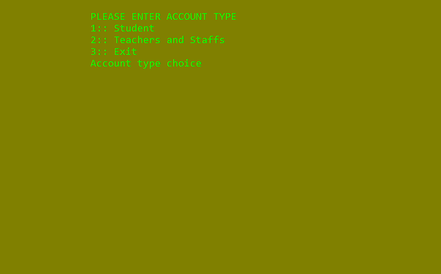

**4.4 Student**

**This screen appears, when option 1:Student is selected.**

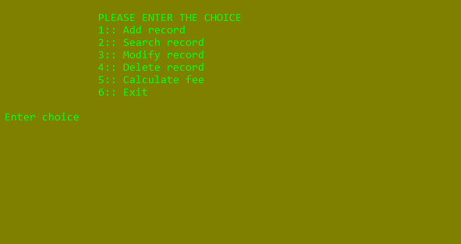

**Here the record of a student can be accessed and maintained.**

**4.5 Teacher**

**This screen appears, when option 2:Teacher and staff is selected.**

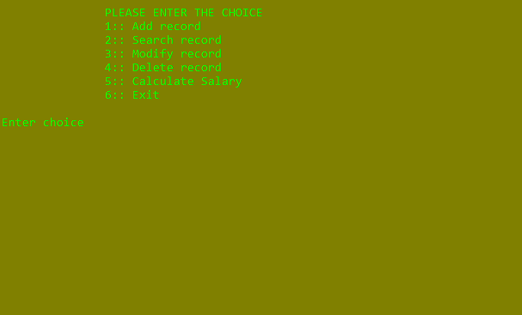

**4.6 Add record**

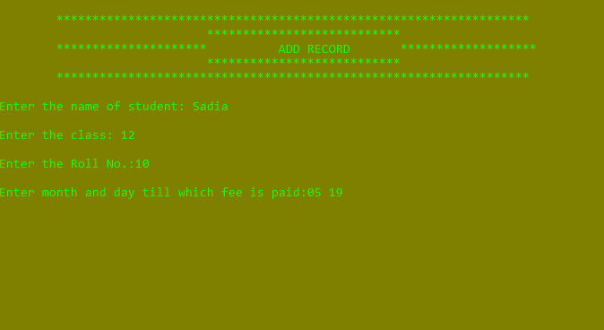

**Record of student is saved.**

**4.7 Search record**

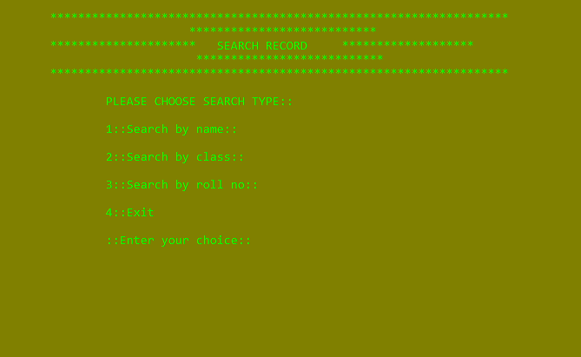

**Enlisting of Record of student whose data will saved here.**

**4.8 Modify record**

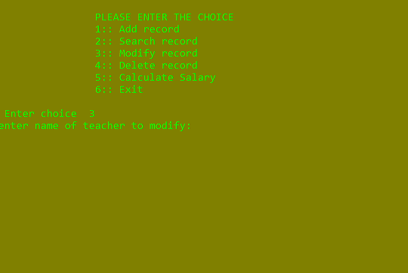

**There is how the record will be Modified.**

**4.9 Delete record**

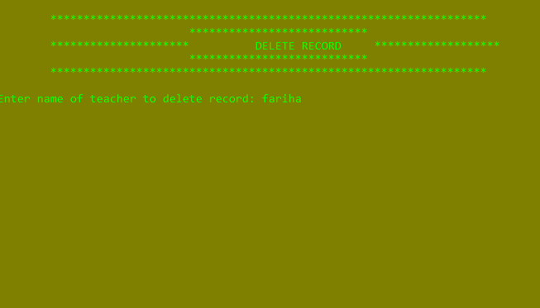

**Here the record will be delete of teacher or employee.**

**4.10 Calculate fee**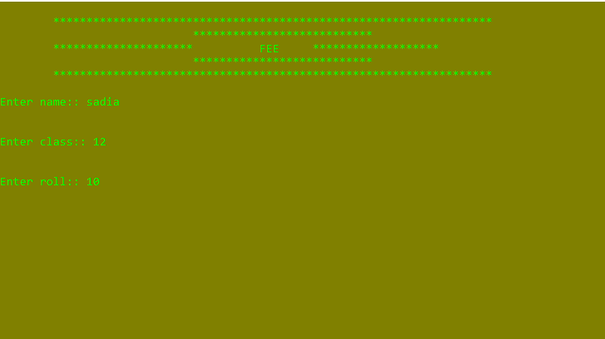

**Here the fee of a student will be calculate.**

**4.11 Calculate salary**

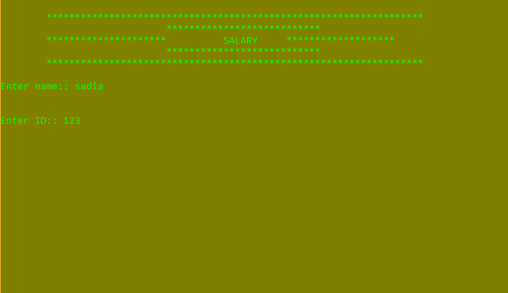

**Here the salary of an employee will be calculate.**

**CHAPTER 5: CONCLUSIONS AND RECOMMENDATIONS**

* 1. **Findings and contributions**

After completing this project :

1. We can easily add any record
2. We can search any record
3. Modify record
4. We can delete record
5. We can also calculate fee and salary
6. There is also an exit option
   1. **Recommendations for future works**
7. We can develop the application in PHP or MYSQL.
8. Applying the SSL for production server.
9. Implementing user management system according permission level.
10. Appling time and skill reducing techniques.
11. Generating report in order application like Excel PDF etc.

**CHAPTER 6 : CONCLUSION**

This system can be operated very easily.There is no need to recruit extra dedicated person or equipment to handle this application.It provides very high level user friendly function.

Main and All Functions Declaration :

APPENDIX-A

void main(void)

{

int i,j,k;

for(i=0; i<120; i++)

{

printf("\xdb");

}

printf("\n");

for(i=0; i<120; i++)

{

printf("\xdb");//it will print a rectangle, \x means hexadecimal number

}

system("color 6a");

printf(" \t____________________________________________________________________________________________________________\n");

printf("\t| |\n");

printf("\t| **WELCOME TO SCHOOL BILLING SYSTEM PROJECT** |\n");

printf("\t| |\n");

printf("\t| MADE BY SADIA SUBRUN PROMA |\n");

printf("\t| ***************************************** |\n");

printf("\t| ***************************************** |\n");

printf("\t|___________________________________________________________________________________________________________|\n");

printf("\n\tPLEASE ENTER ANY KEY TO CONTINUE");

for(i=0; i<5; i++)

{

printf(".");

}

getch();

system("CLS");//clears the screen

printf("\n");

for(i=0; i<120; i++)

{

printf("\xdb");

}

system("color 6A");

printf("\n\n\t ** WELCOME TO C PROGRAM SCHOOL BILLING SYSTEM PROJECT **\n\n\n");

for(i=0; i<120; i++)

{

printf("\xdb");

}

printf("\nPLEASE ENTER ANY KEY TO START\n");

for(i=0; i<5; i++)

{

printf(".");

}

fflush(stdin);

getch();

system("CLS");//screen clear

system("color 6A");//1st is for back ground color and second is for text color

printf("\n\t\tPLEASE ENTER CURRENT DATE\nmm dd yy\n ");

scanf("%d%d%d",&mm,&dd,&yy);

mm=chkdat(mm,dd);

start();

}

void start();

void addrec(int);

void searchrec(int);

void modrec(int);

void delrec(int);

void salary(int);

void fee(int);

void ext();

int chkdat(int,int);

int clscanf();

APPENDIX: B

Start:

void start()

{

int i,j;//j is for selection of account type

system("CLS");

printf("\n\t\tPLEASE ENTER ACCOUNT TYPE");

printf("\n\t\t1:: Student");

printf("\n\t\t2:: Teachers and Staffs");

printf("\n\t\t3:: Exit");

printf("\n\t\tAccount type choice ");

fflush(stdin);

scanf("%d",&j);

switch (j)

{

case 3:

ext();

case 1:

{

system("CLS");

printf("\n\t\tPLEASE ENTER THE CHOICE");

printf("\n\t\t1:: Add record");

printf("\n\t\t2:: Search record");

printf("\n\t\t3:: Modify record");

printf("\n\t\t4:: Delete record");

printf("\n\t\t5:: Calculate fee");

printf("\n\t\t6:: Exit");

printf("\n\n Enter choice ");

fflush(stdin);

scanf("%d",&i);

switch (i)

{

case 1:

addrec(j);//function call

start();//function call

case 2:

searchrec(j);

start();

case 3:

modrec(j);

start();

case 4:

delrec(j);

start();

case 5:

fee(mm);

start();

case 6:

ext();

default :

{

printf("\n\n\tInvalid entry!!");

printf("\n\nTo Account Type\n\n\t");

system("pause");

start();

}

}

}

case 2:

{

system("CLS");

printf("\n\t\tPLEASE ENTER THE CHOICE");

printf("\n\t\t1:: Add record");

printf("\n\t\t2:: Search record");

printf("\n\t\t3:: Modify record");

printf("\n\t\t4:: Delete record");

printf("\n\t\t5:: Calculate Salary");

printf("\n\t\t6:: Exit");

printf("\n\n Enter choice ");

fflush(stdin);

scanf("%d",&i);

switch (i)

{

case 1:

addrec(j);

start();

case 2:

searchrec(j);

start();

case 3:

modrec(j);

start();

case 4:

delrec(j);

case 5:

salary(mm);

start();

case 6:

ext();

default :

{

printf("\n\n\tInvalid entry!!");

printf("\n\nTo Account Type\n\n\t");

system("pause");

start();

}

}

}

default :

{

printf("\n\n\tInvalid entry!!");

printf("\n\nTo Account Type\n\n\t");

system("pause");

start();

}

}

}

APPENDIX: C

ADD Record:

void addrec(int j)

{

int dif,cdat,ddat,month=0;//cdat=month till which fee is cleared

float ff;//used in calculation of fee of different class

char c='y';

system("CLS");

printf("\n\t******************************************************************");

printf("\n\t *************************** ");

printf("\n\t********************* ADD RECORD *******************");

printf("\n\t *************************** ");

printf("\n\t******************************************************************");

if (j==1)

{

while(c=='y'||c=='Y')

{

int a=1;

printf("\n\nEnter the name of student: ");

fflush(stdin);

scanf("%[^\n]",stud.n);

printf("\nEnter the class: ");

fflush(stdin);

stud.c=clscanf();

printf("\nEnter the Roll No.:");

fflush(stdin);

scanf("%2d",&stud.r);

printf("\nEnter month and day till which fee is paid:");

fflush(stdin);

scanf("%2d%2d",&cdat,&ddat);

cdat=chkdat(cdat,ddat);

stud.dt.m=cdat;

ff=stud.c/10.0;

stud.f=1000*(1+ff);//fee of different classes

dif=mm-stud.dt.m;//months of fee left to be paid

stud.fine=(dif*stud.f)*1/100;

stud.due=(dif)*stud.f;//fees left to be paid

if(dif==1)

{

stud.tot=stud.f;

stud.fine=0;

}

else

{

stud.tot=stud.fine+stud.due;

}//for calculation of total fee

fs=fopen("student","ab+");//opening a binary file in append mode

fwrite(&stud,sizeof(stud),1,fs);

fclose(fs);

printf("\n\nDo you want to continue with the process(press y or Y");

fflush(stdin);

c=getch();

}

getch();

}

if (j==2)

{

while(c=='y'||c=='Y')

{

int a=1;

printf("\n\nEnter name of teacher/staff:" );

fflush(stdin);

scanf("%[^\n]",tech.n);

printf("\nEnter teacher/staff id: ");

fflush(stdin);

scanf("%d",&tech.id);

printf("\nEnter number of class/shift per month:: ");

scanf("%d",&tech.no);

fflush(stdin);

printf("\nEnter month and day till which salary is paid::");

scanf("%d %d",&tech.dt.m,&tech.dt.d);

cdat=chkdat(cdat,ddat);

tech.dt.m=cdat;

tech.sal=tech.no*500;

tech.adv=(tech.dt.m-mm-1)*tech.sal;

if (tech.adv<0) tech.adv=0;

tech.tot=tech.sal;

ft=fopen("teacher","ab+");

fwrite(&tech,sizeof(tech),1,ft);

fclose(ft);

printf("\n\nDo you want to continue with the process(press y or Y");

fflush(stdin);

c=getch();

}

fflush(stdin);

printf("\n\n");

system("pause");

}

}

APPENDIX: D

Record Searching:

void searchrec(int j)

{

char name[50],namet[50];

int a=1,choice;

char c='y';

if (j==1)

{

while(c=='y'||c=='Y')

{

int a=1;

system("CLS");

printf("\n\t******************************************************************");

printf("\n\t *************************** ");

printf("\n\t********************* SEARCH RECORD *******************");

printf("\n\t *************************** ");

printf("\n\t******************************************************************");

printf("\n\n\t\tPLEASE CHOOSE SEARCH TYPE::");

printf("\n\n\t\t1::Search by name::");

printf("\n\n\t\t2::Search by class::");

printf("\n\n\t\t3::Search by roll no::");

printf("\n\n\t\t4::Exit");

printf("\n\n\t\t::Enter your choice:: ");

fflush(stdin);

scanf("%d",&choice);

if (choice==1)

{

a=1;

printf("\n\nEnter name of student to search: ");

fflush(stdin);

scanf("%[^\n]",name);

fs=fopen("student","RB");

while(fread(&stud,sizeof(stud),1,fs)==1)

{

if (strcmpi(name,stud.n)==0)

{

a=0;

printf("\nname = %s",stud.n);

printf("\nclass = %d",stud.c);

printf("\nroll no = %d",stud.r);

printf("\nmonthly fee =%.2f",stud.f);

printf("\nlast fee paid in month =%2d",stud.dt.m);

printf("\n due=%.2f",stud.due);

printf("\n fine=%.2f",stud.fine);

printf("\n total=%.2f\n\n",stud.tot);

}

}

if (a==1)

printf("\n\nRECORD NOT FOUND");

printf("\n\n");

system("pause");

fflush(stdin);

fclose(fs);

}

else if (choice==2)

{

int cl;

a=1;

printf("\n\nEnter class of student to search: ");

fflush(stdin);

cl=clscanf();

fs=fopen("student","RB");

while(fread(&stud,sizeof(stud),1,fs)==1)

{

if (stud.c==cl)

{

a=0;

printf("\nname = %s",stud.n);

printf("\nclass = %d",stud.c);

printf("\nroll no = %d",stud.r);

printf("\nmonthly fee =%.2f",stud.f);

printf("\nlast fee paid in month =%2d",stud.dt.m);

printf("\n due=%.2f",stud.due);

printf("\n fine=%.2f",stud.fine);

printf("\n total=%.2f",stud.tot);

}

}

if (a==1)

printf("\n\nRECORD NOT FOUND");

printf("\n\n");

system("pause");

fflush(stdin);

fclose(fs);

}

else if (choice==3)

{

int rll;

a=1;

printf("\n\nEnter roll of student to search: ");

fflush(stdin);

rll=clscanf();

fs=fopen("student","RB");

while(fread(&stud,sizeof(stud),1,fs)==1)

{

if (strcmpi(name,stud.n)==0)

{

a=0;

printf("\nname = %s",stud.n);

printf("\nclass = %d",stud.c);

printf("\nroll no = %d",stud.r);

printf("\nmonthly fee =%.2f",stud.f);

printf("\nlast fee paid in month =%2d",stud.dt.m);

printf("\n due=%.2f",stud.due);

printf("\n fine=%.2f",stud.fine);

printf("\n total=%.2f",stud.tot);

}

}

if (a==1)

printf("\n\nRECORD NOT FOUND");

printf("\n\n");

system("pause");

fflush(stdin);

fclose(fs);

}

else if(choice==4)

{

ext();

}

else

{

printf("\n\n\n\t\tINVALID ENTRY!!!!\n\n\t\t");

system("pause");

searchrec(1);

}

printf("\n\nDo you want to continue with the process(press y or Y");

fflush(stdin);

c=getch();

}

getch();

}

if (j==2)

{

while(c=='y'||c=='Y')

{

int a=1;

printf("\n\nname of teacher/staff to search: ");

fflush(stdin);

scanf("%[^\n]",namet);

ft=fopen("teacher","RB");

while(fread(&tech,sizeof(tech),1,ft)==1)

{

if (strcmp(namet,tech.n)==0)

{

a=0;

printf("\nname = %s",tech.n);

printf("\nteacher/staff id = %d",tech.id);

printf("\nmonth till when salary is paid =%d",tech.dt.m);

printf("\nmonthly salary = %.2f",tech.sal);

printf("\nadvance paid = %.2f",tech.adv);

}

}

if (a==1)

printf("\n\nRECORD NOT FOUND");

printf("\n\n");

system("pause");

fflush(stdin);

fclose(ft);

printf("\n\nDo you want to continue with the process(press y or Y");

fflush(stdin);

c=getch();

}

getch();

}

}

APPENDIX: E

Modify Record:

void modrec(int j)

{

char name[50];

int a=1,choice,cl,rolno;

char c='y';

if (j==1)

{

while(c=='y'||c=='Y')

{

system("CLS");

printf("\n\t******************************************************************");

printf("\n\t *************************** ");

printf("\n\t********************* MODIFY RECORD *******************");

printf("\n\t *************************** ");

printf("\n\t******************************************************************");

printf("\n\n\t\tPLEASE CHOOSE MODIFY TYPE::");

printf("\n\n\t\t1::Modify by name::");

printf("\n\n\t\t2::Modify by name &class::");

printf("\n\n\t\t3::Modify by name,class & roll no::");

printf("\n\n\t\t4::Exit");

printf("\n\n\t\t::Enter your choice:: ");

fflush(stdin);

scanf("%d",&choice);

if (choice==1)

{

int a=0;

printf("\n\nenter name of student to modify: ");

fflush(stdin);

scanf("%[^\n]",name);

fs=fopen("student","RB+");

while(fread(&stud,sizeof(stud),1,fs)==1)

{

a=1;

if (strcmpi(name,stud.n)==0)

{

a=0;

printf("\nenter new name of student: ");

fflush(stdin);

scanf("%[^\n]",stud.n);

printf("\nenter new class of student: ");

fflush(stdin);

stud.c=clscanf();

printf("\nenter new roll of student: ");

fflush(stdin);

scanf("%d",&stud.r);

fseek(fs,-sizeof(stud),SEEK_CUR);

fwrite(&stud,sizeof(stud),1,fs);

fclose(fs);

}

}

if (a==1)

printf("\n\nRECORDS NOT FOUND");

else

printf("\n\nRECORDS SUCCESSFULLY MODIFIED");

printf("\n\n");

system("pause");

}

else if (choice==2)

{

int a=0;

printf("\n\nenter name of student to modify: ");

fflush(stdin);

scanf("%[^\n]",name);

printf("\n\nenter class of student to modify: ");

fflush(stdin);

cl=clscanf();

fs=fopen("student","RB+");

while(fread(&stud,sizeof(stud),1,fs)==1)

{

a=1;

if (strcmpi(name,stud.n)==0 && cl==stud.c)

{

a=0;

printf("\nenter new name of student: ");

fflush(stdin);

scanf("%[^\n]",stud.n);

printf("\nenter new class of student: ");

fflush(stdin);

stud.c=clscanf();

printf("\nenter new roll of student: ");

fflush(stdin);

scanf("%d",&stud.r);

fseek(fs,-sizeof(stud),SEEK_CUR);

fwrite(&stud,sizeof(stud),1,fs);

fclose(fs);

}

}

if (a==1)

printf("\n\nRECORDS NOT FOUND");

else

printf("\n\nRECORDS SUCCESSFULLY MODIFIED");

printf("\n\n");

system("pause");

}

else if (choice==3)

{

int a=0;

printf("\n\nenter name of student to modify: ");

fflush(stdin);

scanf("%[^\n]",name);

printf("\n\nenter class of student to modify: ");

fflush(stdin);

cl=clscanf();

printf("\n\nenter roll of student to modify: ");

fflush(stdin);

scanf("%d",&rolno);

fs=fopen("student","rb+");

while(fread(&stud,sizeof(stud),1,fs)==1)

{

a=1;

if (strcmpi(name,stud.n)==0 && cl==stud.c &&rolno==stud.r)

{

a=0;

printf("\nenter new name of student: ");

fflush(stdin);

scanf("%[^\n]",stud.n);

printf("\nenter new class of student: ");

fflush(stdin);

stud.c=clscanf();

printf("\nenter new roll of student: ");

fflush(stdin);

scanf("%d",&stud.r);

fseek(fs,-sizeof(stud),SEEK_CUR);

fwrite(&stud,sizeof(stud),1,fs);

fclose(fs);

}

}

if (a==1)

printf("\n\nRECORDS NOT FOUND");

else

printf("\n\nRECORDS SUCCESSFULLY MODIFIED");

printf("\n\n");

system("pause");

}

else if (choice==4) ext();

else

{

printf("\n\n\n\t\tINVALID ENTRY!!!!\n\n\t\t");

system("pause");

modrec(1);

}

printf("\n\nDo you want to continue with the process(press y or Y");

fflush(stdin);

c=getch();

}

getch();

}

if (j==2)

{

while(c=='y'||c=='Y')

{

int a=1;

printf("enter name of teacher to modify: ");

fflush(stdin);

scanf("%[^\n]",name);

ft=fopen("teacher","RB+");

while(fread(&tech,sizeof(tech),1,ft)==1)

{

if (strcmpi(name,tech.n)==0)

{

a=0;

printf("\nenter new name of teacher: ");

fflush(stdin);

scanf("%[^\n]",tech.n);

printf("\nenter new id of teacher: ");

fflush(stdin);

scanf("%d",&tech.id);

fseek(ft,-sizeof(tech),SEEK_CUR);

fwrite(&tech,sizeof(tech),1,ft);

fclose(ft);

}

}

if (a==1)

printf("\n\nRECORD NOT FOUND");

else

printf("\n\nRECORD SUCCESSFULLY MODIFIED");

printf("\n\n");

system("pause");

fflush(stdin);

printf("\n\nDo you want to continue with the process(press y or Y");

fflush(stdin);

c=getch();

}

getch();

}

}

APPENDIX: F

Delete Record:

void delrec(int j)

{

system("CLS");

printf("\n\t******************************************************************");

printf("\n\t *************************** ");

printf("\n\t********************* DELETE RECORD *******************");

printf("\n\t *************************** ");

printf("\n\t******************************************************************");

FILE *temp,*t1;

int a=1;

char name[50],c='y';

if (j==1)

{

while(c=='y'||c=='Y')

{

int a=1;

printf("\n\nenter name of student to delete: ");

fflush(stdin);

scanf("%[^\n]",name);

fs=fopen("student","RB");

temp=fopen("temp file","WB");//opening of temporary file for deleting process

while (fread(&stud,sizeof(stud),1,fs)==1)

{

if (strcmp(stud.n,name)==0)

{

a=0;

continue;

}

else

{

fwrite(&stud,sizeof(stud),1,temp);

}

}

if (a==1)

printf("\n\nRECORD NOT FOUND");

else

printf("\n\nRECORD SUCCESSFULLY DELETED");

printf("\n\n");

system("pause");

fflush(stdin);

fclose(fs);

fclose(temp);

system("DEL student");/*all data except the data to be

deleted in student were 1st moved to temp and data in student

was deleted*/

system("REN temp file, student");//renaming temp to student

printf("\n\nDo you want to continue with the process(press y or Y");

fflush(stdin);

c=getch();

}

getch();

}

if (j==2)

{

a=1;

char namet[50];

while(c=='y'||c=='Y')

{

printf("\n\nEnter name of teacher to delete record: ");

fflush(stdin);

scanf("%[^\n]",namet);

ft=fopen("teacher","RB");

t1=fopen("temp file1","WB");

while (fread(&tech,sizeof(tech),1,ft)==1)

{

if (strcmp(tech.n,namet)==0)

{

a=0;

continue;

}

else

{

fwrite(&tech,sizeof(tech),1,t1);

}

}

if (a==1)

printf("\n\nRECORD NOT FOUND");

else

printf("\n\nRECORD SUCCESSFULLY DELETED");

printf("\n\n");

system("pause");

fflush(stdin);

fclose(ft);

fclose(t1);

system("DEL teacher");

system("REN temp file1, teacher");

printf("\n\nDo you want to continue with the process(press y or Y");

fflush(stdin);

c=getch();

}

getch();

}

}

APPENDIX: G

Calculate Salary:

void salary(int mm)

{

system("CLS");

printf("\n\t******************************************************************");

printf("\n\t *************************** ");

printf("\n\t********************* SALARY *******************");

printf("\n\t *************************** ");

printf("\n\t******************************************************************");

FILE *f,*t;

int a=1,day;

char name[50],c='y';

int month,dif,id;

while(c=='y'||c=='Y')

{

int a=1;

fflush(stdin);

printf("\n\nEnter name:: ");

scanf("%[^\n]",name);

printf("\n\nEnter ID:: ");

scanf("%d",&id);

f=fopen("teacher","RB+");

t=fopen("TE","WB+");

while(fread(&tech,sizeof(tech),1,f)==1)//file opened

{

if(strcmp(tech.n,name)==0 )//name entered is compared to the existing name in file

{

float lsal;

a=0;

printf("\n\nEnter the month till which salary is to be paid:: ");

fflush(stdin);

scanf("%d",&month);

month=chkdat(month,day);

tech.adv=(month-mm-1)*tech.sal;

if (tech.adv<0) tech.adv=0;

lsal=mm-tech.dt.m;//months of salary left to be paid

if(lsal<0) lsal=0;

tech.tot=tech.adv+tech.sal*(1+lsal);

if(month==tech.dt.m) tech.tot=0;

printf("\nmonthly salary left to be paid:: %.2f",lsal);

printf("\ntotal :: %.2f",tech.tot);

printf("\nadvance :: %.2f",tech.adv);

tech.dt.m=month;

fwrite(&tech,sizeof(tech),1,t);

fclose(f);

fclose(t);

if (a==1)

printf("\n\nRECORD NOT FOUND");

printf("\n\n");

system("pause");

fflush(stdin);

system("DEL teacher");

system("REN TE, teacher");

}

}

printf("\n\nDo you want to continue with the process(press y or Y");

fflush(stdin);

c=getch();

}

getch();

}

APPENDIX: H

Calculate Fee:

void fee(int mm)

{

system("CLS");

printf("\n\t******************************************************************");

printf("\n\t *************************** ");

printf("\n\t********************* FEE *******************");

printf("\n\t *************************** ");

printf("\n\t******************************************************************");

FILE *f,*t;

int a=0;

char name[50],c='y';

int clas, roll,month,dif;

while(c=='y'||c=='Y')

{

int a=1,day=0;

fflush(stdin);

printf("\n\nEnter name:: ");

scanf("%[^\n]",name);

printf("\n\nEnter class:: ");

fflush(stdin);

clas=clscanf();

printf("\n\nEnter roll:: ");

fflush(stdin);

scanf("%d",&roll);

f=fopen("student","RB+");

t=fopen("TE","WB");

while(fread(&stud,sizeof(stud),1,f)==1)

{

if(strcmp(stud.n,name)==0 && clas==stud.c && roll==stud.r)

{

a=0;

printf("\n\nEnter the month till which fee to be paid:: ");

fflush(stdin);

scanf("%d",&month);

month=chkdat(month,day);

dif=mm-stud.dt.m;

stud.fine=(dif*stud.f)*0.01;

stud.due=(dif)*stud.f;

if (stud.fine<0) stud.fine=0;

if (stud.due<0) stud.due=0;

if (stud.tot<0) stud.tot=0;

stud.tot=stud.fine+stud.due+stud.adv;

printf("\nfine :: %.2f",stud.fine);

printf("\ndue :: %.2f",stud.due);

printf("\ntotal :: %.2f",stud.tot);

printf("\nadvance :: %.2f",stud.adv);

stud.dt.m=month;

stud.tot=0;

stud.fine=0;

stud.due=0;

fwrite(&stud,sizeof(stud),1,t);

}

}

if (a==1)

printf("\n\nRECORD NOT FOUND");

printf("\n\n");

system("pause");

fflush(stdin);

fclose(f);

fclose(t);

system("DEL student");

system("REN TE, student");

printf("\n\nDo you want to continue with the process(press y or Y");

fflush(stdin);

c=getch();

}

getch();

}

APPENDIX: I

Exit:

void ext()

{

int i;

system("color 0c");

printf("\n\n\t\t Thank you for using C Program School Billing System Project\n\n");

system("pause");

system("CLS");

printf("\n\n\t\t\t Exiting\n\n");

for(i=1; i<=80; i++)

{

Sleep(50);

printf("*");

}

exit(0);

}

APPENDIX: J

Check Date:

int chkdat(int mnt,int dnt)

{

int mon,day;

if (mnt>12 || mnt<1 || dnt<1 || dnt>32)

{

MessageBox(0,"Invalid Date!\nEnter Again","Error!",0);

fflush(stdin);

scanf("%d%d",&mon,&day);

mon=chkdat(mon,day);

}

else

return (mnt);

}